Kids’ Camp 2021
What is Kids’ Camp? Kids’ Camp is an opportunity for kids to learn about the Police Department and First Responders. Kids will be divided into teams and will play games and compete with one another while learning about teamwork.
Who can attend? City of Madison public school, City of Madison private school, and City of Madison home school fifth grade students graduating to sixth grade.
Where it is? Discovery Middle School 8:00am till 3:00pm each day.
When is it? June 14-18, 2021: Horizon, West Madison, Heritage
June 21-25, 2021: Madison, St. John, Columbia
June 28-July 2, 2021: Mill Creek, Rainbow, Home School
Questions? Contact Officer Shane Kyker @ (407) 376-7405, or Sgt. Ralph Dawe @ (256) 836-0590
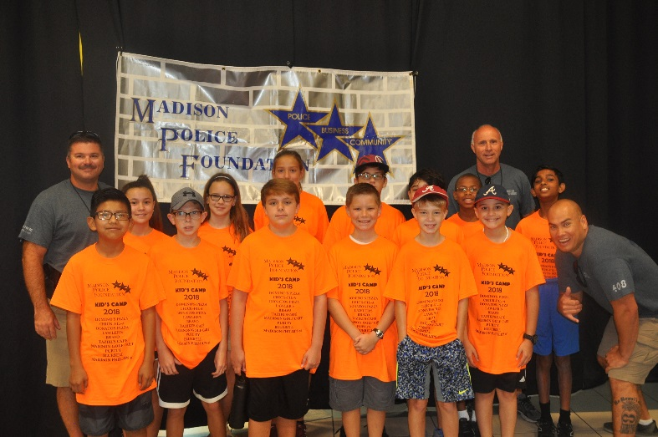
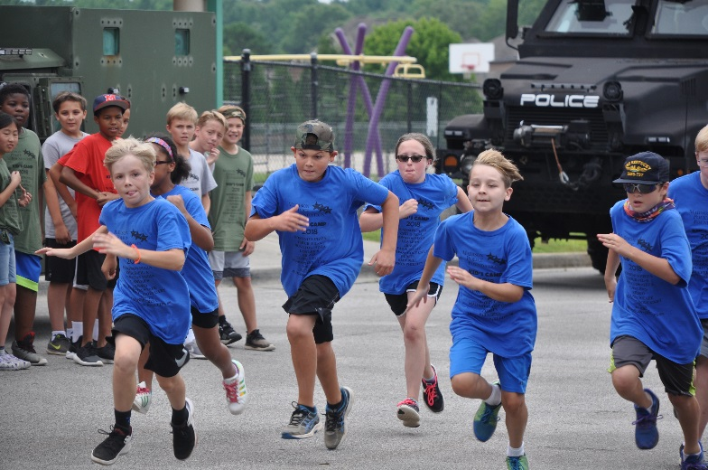
How much does it cost? There is a $50.00 registration cost. Attach cash or check to the application or you can pay online at Madisonpolicefoundation.org. Go to Kids’ Camp under events.
SCHEDULE  Monday  8:00-8:30: Check in/Registration  8:30: Welcome Speech with Chief  9:00: Air Evac, Hemsi, Fire, Police  11:00-11:30: Lunch  11:30-1:00: Too Good For Drugs Lecture  1:00-2:45: Dodgeball/Kickball, Ice Cream, Clean Up  2:45: Dismissal  Tuesday (@ Insanity Skate Park)  8:00: Arrival @ Insanity Skate Park  8:15-9:15: K9 Demo  9:15-11:30: Drunk Driving Demo With Golf Carts  11:30-2:45: Lunch/Free Time at Insanity Skate Park  2:45: Dismissal  Wednesday  8:00: Arrival  8:15-10:30: Swat Demo  10:30-11:30: Relay Races  11:30-12:00: Lunch  12:00-1:30: Too Good For Drugs Lecture  1:30-2:45: Dodgeball/Kickball  2:45: Dismissal  Who is in charge of Kids’ Camp?  The Madison City Police SRO’s (School Resource Officers) and volunteers will be responsible for training and supervising the children who are attending Kids Camp each day. | Thursday  8:00: Arrival  8:30: Leave for Dublin Park  9:00-11:00: Pool Time  11:00: Enroute to Discovery  11:00-11:30: Lunch  11:30-12:00: Dance Competition  12:00-1:00: Too Good For Drugs Lecture  1:00-2:15: Mud Day  2:15-2:45: Clean Up/Ice Cream  2:45: Dismissal  Friday  8:00: Arrival  8:30-9:30: Too Good For Drugs Lecture  9:30-11:00: Dodgeball/Kickball  11:00-11:30: Lunch  11:30-12:30: Bag Toss Tournament  12:30-1:30: Dodgeball/Kickball  1:30-2:00: Clean Up  2:00: Graduation  What should I send with my child to Camp?  Parents and Guardians should provide their child with a hat, sunscreen, towel, mask, and water bottle. Your child may get wet and dirty each day, so be prepared when picking them up. Please wash the shirt that will be provided by Kids’ Camp each night. Children will be required to wear the shirt each day. Due to hot weather, it is suggested that children wear shorts.

Kids’ Camp 2021
Application Form
To be completed by Parent/Guardian (Please Print)

Applicants Name:
 |  |  |  |  |  |  | Last Name |  |  |  | First Name |  |  |  |  |  |  | MI
Address:
Sex: |  |  |  |  |  | Date of Birth: |  |  |  | Age: |  |  | T-Shirt Size:
Male/Female |  |  |  |  |  |  | M/D/YR |  |  |  |  |  | Youth Sizes |  |  | YSM/YMD/YLG/YXL
School:
Parent/Guardian:
 |  |  |  |  |  |  | Last Name |  |  |  | First Name |  |  |  |  |  |  | MI
Relation to child:
Home Phone: |  |  |  |  |  |  |  |  | Cell Phone:
E-Mail:
Emergency Contact:
Name: |  |  |  |  |  |  |  |  |  |  |  |  |  | Phone:
Address:
Relation to Child:

Will anyone other than the parent or guardian listed above be picking up the child at any time during Kids’ Camp? If so, who?

______________________________________________________________________________

Additional information you would like to add? ________________________________________

______________________________________________________________________________

Signature of Parent/Guardian |  | Date
Make Checks Payable to: Madison Police Foundation
*Completed registration forms due by midnight April 30, 2021. Thank You!

Kids’Camp 2021
Registration Agreement:
Health and Medical Summary

To be completed by Parent/Guardian

___________________________________________________________________________
__________

Camper’s Name: ____________________________________________________________________

Parent/Guardian Name: _______________________________________________________________

Home Address: ____________________________________________________Phone: ____________

E-Mail:_____________________________________________________________________________

Emergency Contact:

Name: _________________________________Relationship________________Phone:____________

Name of Family Physician: ___________________________________________Phone:____________

Personal Health Insurance Carrier: _______________________________________________________

Contract #: _____________________Group #: ______________________ID #:___________________

Circle appropriate answer on camper’s behalf, and explain “Yes” answers on back:
Have you ever been hospitalized? | Yes | No
Have you ever passed out during or after exercise? | Yes | No
Do you have high blood pressure? | Yes | No
Do you have heart disease? | Yes | No
Do you have any allergies or skin problems? | Yes | No
Do you have or have you had any form of cancer? | Yes | No
Do you have diabetes? | Yes | No
Have you ever had a head injury? | Yes | No
Have you ever been unconscious? | Yes | No
Have you ever had or do you have seizures? | Yes | No
Do you have trouble breathing during or after activity? | Yes | No
Do you wear glasses? | Yes | No
Have you ever sprained, dislocated, fractured, or broken any bones or joints? | Yes | No
Do you use any special equipment (pads, braces, eye guards, etc.)? | Yes | No
Any reason to restrict full activity from swimming, long hikes, backpacking, or
strenuous physical games? Yes  Are your immunizations up-to-date (as required by the American Pediatrics |  | No
Association)? Yes No
Are you currently taking any medications? Yes No

*Note to Parent/Guardian: Please be sure that your Camper has taken all appropriate medication doses before arriving for Kids’ Camp. Be advised that the Madison Police Department will not be responsible for administering any prescription or over-the-counter medications to Campers. In the event that your Camper has a known medical condition that may require immediate treatment from an inhaler, EpiPen, etc., please contact Officer Kyker to discuss your Camper’s individual needs.

I hereby state that, to the best of my knowledge, my answers to the above questions are correct, and I have also read and hereby acknowledge the note to Parent/Guardian above.

Signature of Parent/Guardian Date

WAIVER TO CARRY EPIPEN/ASTHMA INHALER
Parent/Guardian, you must complete this section if your Camper will be carrying an EpiPen or asthma inhaler during Kids’ Camp.

Due to the potential necessity for immediate medication distribution imposed by my child’s life-threatening condition, I ___________________________ (parent/guardian) hereby request that _________________________ (Camper) be allowed to keep the appropriate prescribed device
on his/her person while participating in all Kids’ Camp activities.

The prescribed device(s) is/are: EpiPen Asthma inhaler

I understand that in order to participate in Kids’ Camp, my child must be capable of safely storing the necessary EpiPen or asthma inhaler on his/her person (fanny pack or pocket) and using the device appropriately.

Signature of Parent/Guardian Date

(
Camper’s Name)

Kids’ Camp 2021

Registration Agreement:
Waiver & Release

To be completed by Parent/Guardian (Please Print)

As the parent and/or legal guardian of _______________________________, a minor child (“Camper”), I do hereby acknowledge that I have read and understand this Waiver & Release and that I do voluntarily execute the same on behalf of Camper and do hereby consent to and give permission for Camper’s participation in all Kids’ Camp activities. I further state specifically that I am aware that these activities will include strenuous physical requirements as well as certain risks, including, but not limited to, illness, injury, and death. I understand and agree that Kids’ Camp attendance is voluntary and elective and that Camper’s participation in Kids’ Camp is being allowed in exchange for the execution of this Waiver & Release and the payment of the registration fee. As bargained for, I agree, for myself and for Camper, as follows:

- I authorize the Madison Police Department to obtain emergency medical care, including but not limited to first aid, transport, or treatment by medical personnel onsite or at a hospital or other medical facility, which, at the discretion of City of Madison employees, may become necessary for my child in the course of Kids’ Camp activities. I also accept full responsibility for payment of all medical bills my child may incur by reason of participation in such activities, including but not limited to, charges for doctors, ambulances, other transportation, hospitals or other medical facilities, and any and all medication(s) administered.

- I have provided all relevant health information about my child in the Kids’ Camp Health and Medical Summary, and I certify that it is true and correct. I certify that I have disclosed on that form any and all medical conditions my child has, and I have explained fully those that may impact his or her participation in the strenuous physical activities of Kids’ Camp.

- I authorize the Madison Police Department and the City of Madison Board of Education to transport my child to and from activities scheduled away from Discovery Middle School, as well as to Insanity Skate Park.

- I understand both that Kids’ Camp involves taxing physical activities in hot and humid weather and that Kids’ Camp involves activities at Insanity Skate Park. Camp activities may include, but are not limited to: dodge ball; swimming; mud and water games; roller skating and/or roller blading in an indoor rink with strobe lights, flashing lights, dim lighting, loud music, and loud or alarming bells, sirens, or other sounds; arcade games which may involve motion, flashing lights, loud music and loud or alarming bells, sirens, or other sounds; and an obstacle course on the school track. I acknowledge that such activities may place strenuous physical demands and stresses on the body. I further state that my child is in proper physical condition to participate in such activities.

- I understand that Kids’ Camp involves demonstrations by Madison Police and emergency personnel, including possible demonstrations by Madison Fire and Rescue, HEMSI, and Huntsville MedFlight, and I accept all risks which may accompany Camper’s participation therein.

- I understand that regardless of precautions taken by Kids’ Camp organizers, Camper could be exposed to or contract COVID-19 while participating in Kids’ Camp. I agree that Camper will follow any applicable government guidelines in place at the time of his/her attendance at Kids Camp. I acknowledge that Camper:

  - May choose to wear a mask, not wear a mask, wear a face shield, or take other precautions.
  - Will limit the possibility of COVID-19 exposure or transmission by such means as washing hands and using hand sanitizer.
  - Will not participate in camp if he/she has been in contact with anyone with a confirmed case of COVID-19 within the last 14 days.
  - Will not participate in camp if he/she has had a fever in the last 48 hours or has any symptoms of COVID-19 including cough, shortness of breath, sore throat, or any other symptom.

- In exchange for the consideration of Camper being granted the opportunity to attend Kids’ Camp, I hereby, for myself and my heirs, executors, administrators, successors, and assigns, and on behalf of Camper and for his/her heirs, executors, administrators, successors, and assigns, forever hold harmless, release, acquit, and discharge the City and its agents, servants, successors, assigns, and all other persons, departments, officers, officials, and employees of the City of Madison, Alabama, from any and all claims, actions, causes of action, demands, rights, damages, costs, losses of service, expenses, or compensation whatsoever, which I or the Camper now have or which may accrue on account of or in any way grow out of any and all known or unknown, foreseen or unforeseen, personal and bodily injuries, as well as any and all property damage, and any consequences directly or indirectly resulting, or to result, therefrom which arise from any action or inaction, whether individually or collectively made. I also will not allow any such claims to be made on my behalf, or on the Camper’s behalf, by any family member or friend. Furthermore, I assume all risks of Camper’s participation in Kids’ Camp, and I waive any and all claims and causes of action arising from the unintentional or negligent conduct of the entities listed in this section, and I will indemnify and hold harmless the City of Madison, the Madison Police Foundation, the City of Madison Board of Education, the Madison Police Department, Huntsville MedFlight, HEMSI, and their servants, agents, employees, police officers, cadets, volunteers, and sponsors. I agree that the City of Madison, the Madison Police Foundation, the City of Madison Board of Education, the Madison Police Department, Huntsville MedFlight, HEMSI, and their servants, agents, employees, police officers, cadets, volunteers, and sponsors are released and forever acquitted from any and all claims of liability, which could be brought by me, my child, or my heirs, for illness or injury sustained by my child because of such participation.

- I give permission for the use of Camper’s name and/or picture for use in television broadcasts, promotional materials, or any other public accounts of this event, as well as for Web-based platforms including, but not limited to, City of Madison, Madison Police Foundation, City of Madison School Board, and Madison Police Department Web sites, Facebook pages, and other social media platforms.

- This Waiver and Release contains the entire agreement between the parties hereto and its terms are contractual and not a mere recital. I have read it, I do fully understand it prior to signing it and, by affixing my signature hereto, warrant that I am under no duress or undue influence to execute said document and that I sign the same freely and voluntarily.

- The provisions of this Waiver and Release are intended to be severable and, if any one or more thereof should be held invalid for any reason, the rest shall nevertheless stand and be fully effective.

Print Name of Parent/Guardian

Signature of Parent/Guardian Date

